

PATIENT SUMMARY

Name |  |  | Address
Contact |  |  | Age/Gender
Patient ID | BCH0599553 |  | Reference Doctor
Collection Date | 04-Jan-2024 |  | Report Date | 05-Jan-2024

TEST SUMMARY

- Test Name: infexn™
- Test Method: Next Generation Sequencing
- Report Date: 05-Jan-2024

REPORT SUMMARY
The sample was subjected to infexn™ for the detection of pathogenic genomic signatures.
Pathogen identified: Not Detected

PATIENT SUMMARY

Name |  |  | Address
Contact |  |  | Age/Gender
Patient ID |  |  | Reference Doctor
Collection Date | 04-Jan-2024 |  | Report Date | 05-Jan-2024

ANTIMICROBIAL RESISTANCE SUMMARY
Antibiotic Class | Antibiotics | Gene | Reads
NA | NA | Not detected | NA

PATHOGEN SUMMARY
Pathogen Detected | No of Reads | Proportion of Reads | Remarks
Not detected | NA | NA | NA

SAMPLE SUMMARY
Sample ID | Sample Type | Client ID | Sample Source
S04-BCH0882151 | gDNA | BreachCandy-Hospital | Plasma-Rt hand

PATIENT SUMMARY

Name |  |  | Address
Contact |  |  | Age/Gender
Patient ID |  |  | Reference Doctor
Collection Date | 04-Jan-2024 |  | Report Date | 05-Jan-2024

GENOME SEQUENCE SUMMARY
Sequencer | Run on | Device | FlowCell | Library Date | Library Kit
MinION | 05-Jan-2024 | MN40246 | FID646 | 04-Jan-2024 | SQK-LSK109

GENOME ANALYSIS SUMMARY
Analysis  Date | Application Run By | Barcode  ID | Filtered  Reads | Test ID | Total  Reads
05-Jan-2024 | HAPL | Barcode36 | 83 | OmegaID-3.14 | 183

PATIENT SUMMARY

Name |  |  | Address
Contact |  |  | Age/Gender
Patient ID |  |  | Reference Doctor
Collection Date | 04-Jan-2024 |  | Report Date | 05-Jan-2024

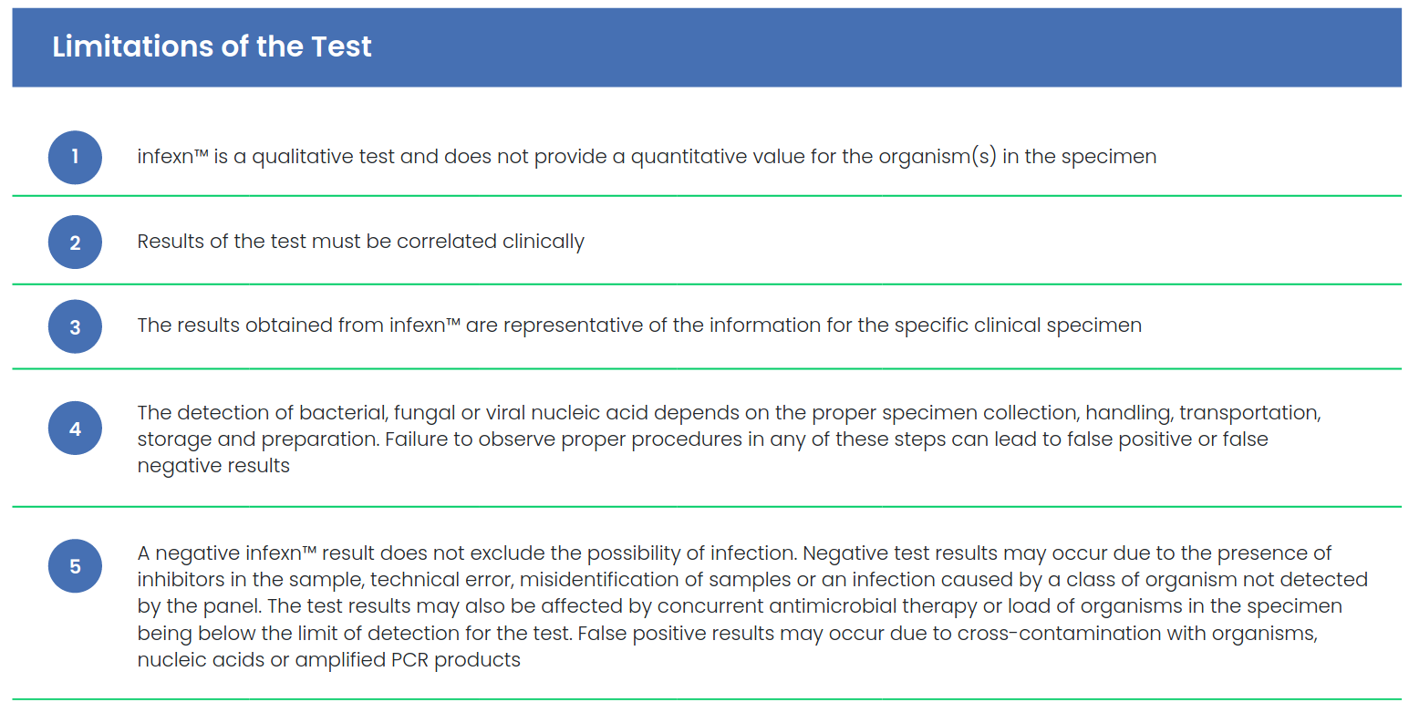

PATIENT SUMMARY

Name |  |  | Address
Contact |  |  | Age/Gender
Patient ID |  |  | Reference Doctor
Collection Date | 04-Jan-2024 |  | Report Date | 05-Jan-2024

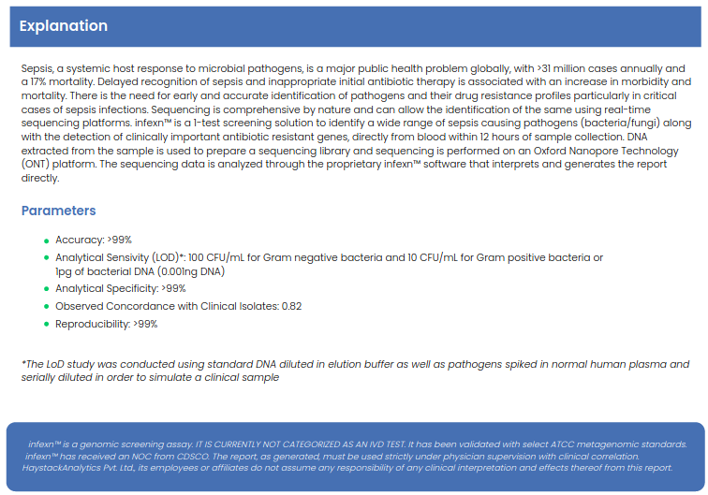

PATIENT SUMMARY

Name |  |  | Address
Contact |  |  | Age/Gender
Patient ID |  |  | Reference Doctor
Collection Date | 04-Jan-2024 |  | Report Date | 05-Jan-2024

